Optimal placement of EV charging station

# objective functions:

The objective functions are:

1. **Traffic flow/ service flow: maximize**

The traffic flow of EV is defined by the number of EVs travelling along the lines or edges connecting the different nodes along the pre-determined travel route. If a charging station is located on the travel route of a certain EV, then the EV may choose to obtain charging service there. In this case, it is expected that fast charging station can serve as many EVs as possible. The traffic network topology, traffic system condition and driving patterns can be well addressed in FCLM for the travelling and charging convenience.

Therefore, the annual captured traffic flow by FCSs is maximized by solving the flow-capturing location model.

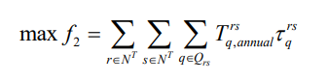

Subject to:

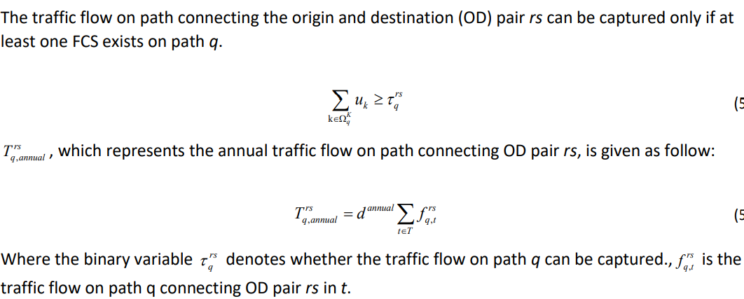

1. **Cost and energy loss: Minimize**

* Installation and operation costs
* Existing infrastructure upgrade

The objective function represents the gross investment cost of joint planning project (cost of installation operation cost, DG installations, upgrade of existing protection devices etc.)

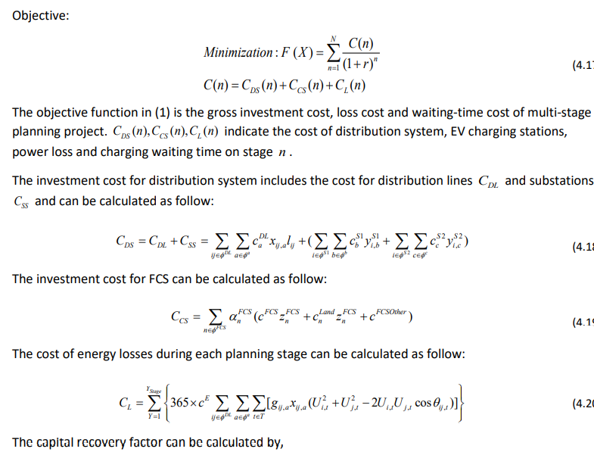 Capital Recovery factor

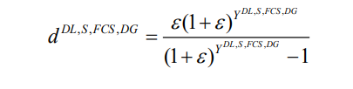

Here, γ represents corresponding lifespan of fast charging station and distribution generation. And ε represents the Interest rate.

Constraints:

Power flow equation constraints: 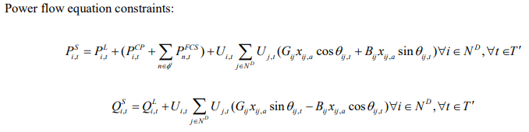

Capacity constraints of Fast Charging Station:



Where *z min* and *z max* are the size limits of Fast Charging Station.

